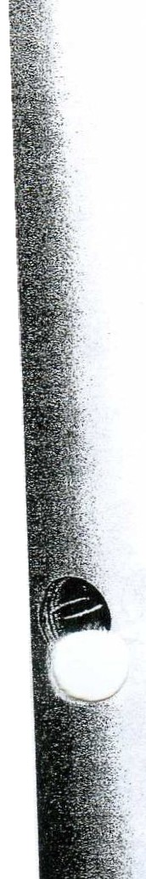

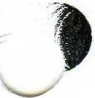

The Skeletal System

ow strange we would look without our skeleton! It is the skeleton that pro­ vides us with the rigid, supportive framework that gives shape to our bodies. But this is just the beginning, since it also protects the organs beneath it, main­
H
tains homeostasis of blood calcium, produces blood cells, and assists the muscular sys­
tem in providing movement for us.

After reviewing the microscopic structure of bone and cartilage, you will understand how skeletal tissues are formed, their differences, and their importance in the human body. Your microscopic investigation will make the study of this system easier as you logically progress from this view to macroscopic bone formation a nd growth and visual­ ize the structure of the long bones.

The skeleton is divided into two main divisions: the axial skeleton and the appendicular skeleton. All of the 206 bones of the human body may be classified into one of these two categories. And, although we can divide the bones neatly by this system, we are still aware that subtle d_ifferences exist between men's and women's skeletons. These struc­ tural differences provide us with insight to the differences in function btween men and women.

Finally, three types of joints exist in the body: synarthroses, amphiarthroses, and diar­ throses. It is important to have knowledge of these joints and to understand how move­ ment is facilitated by these various articulations.

TOPICS FOR REVIEW

Before progressing to Chapter 7, you should familiarize yourself with the functions of the skeletal system, the structure and function of bone and cartilage, bone formation
and growth, and the types of joints found in the body. Additionally, your understanding of the skeletal system should enable you to identify the two major subdivisions of the skeleton, the bones found in each area, and any differences that exist between men's and women's skeletons.

'

Copyright© 2004 Mosby Inc. All rights reserved. 49

50 Chapter 6: The Skeletal System

FUNCTIONS OF THE SKELETAL SYSTEM TYPES OF BONES
STRUCTURE OF LONG BONES

Fill in the blanks.

1. There are types of bones.

2. The is the hollow area inside the diaphysis of a bone.

3. A thin layer of cartilage covering each epiphysis is the-- ---------------
4. The lines the medullary cavity of long bones.

5. is used to describe the process of blood cell formation.

6. Blood cell formation is a vital process carried on in-------------- .

7. The is a strong fibrous membrane covering a long bone except at joint surfaces.

8. Osteoporosis occurs most frequently in--------------------·

9. Bones serve as a safety-deposit box for----------' a vital substance required for normal nerve and muscle function.

10. As muscles contract and shorten, they pull on bones and thereby----------them.

.... If you have had difficulty with this section, review pages 121-124 and page 127.

MICROSCOPIC STRUCTURE OF BONE AND CARTILAGE

Match the term on the left with the proper selection on the right.

Group A
11. Trabeculae A. Outer covering of bone
12. Compact B. Dense bone tissue
13. Spongy c. Fibers embedded in a firm gel
14. Periosteum D. Needlelike threads of spongy bone
15. Cartilage E. Ends of long bones

Group B
16. Osteocytes A. Connect lacunae
17. Canaliculi B. Oirt:ilage cells
18. Lamellae c. Structural unit of compact bone
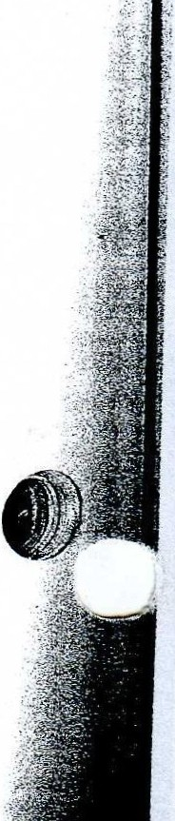· : 19. Chondrocytes D. Bone cells
20. Haversian system E. Ring of bone

If you have had difficulty with this section, review pages 123-124.

Copyright © 2004 Mosby Inc. All rights reserved.

Chapter 6: The Skeletal System 51

BONE FORMATION AND GROWTH
t lf the statement is true, write "T" in the answer blank. If the statement is false, correct the statement by circling the in­
\...._...- correct term and inserting the correct term in the answer blank.

21. When the skeleton forms in a baby before birth, it consists of cartilage and fibrous structures.

22. The diaphyses are the ends of the bone.

23. Bone-forming cells are known as osteoclasts.

24. It is the combined action of osteoblasts and osteoclasts that sculpts bones into their adult shapes.

25. The stresses placed on certain bones during exercise decrease the rate of bone deposition.

26. The epiphyseal plate can be seen in both external and cutaway views of an adult long bone.

27. The shaft of a long bone is known as the articulation.

28. Cartilage in the newborn becomes bone when it is replaced with calcified bone matrix deposited by osteoblasts.

29. When epiphyseal cartilage becomes bone, growth begins.

30. The epiphyseal cartilage is visible, if present, on x-ray films.

If you have had difficulty with this section, review pages 125-127.

DIVISIONS OF SKELETON

Circle the correct choice.
31. Which one of the following is not a part of the axial skeleton?
A. Scapula
B. Cranial bones
C. Vertebra
D. Ribs
E. Sternum
32. Which one of the following is not a cranial bone?
A. Frontal B. Parietal C. Occipital D. Lacrimal
E. Sphenoid
33. WhiCh of the following statements is not true?
A. A baby is born with a straight spine.
B. In the adult, the sacx:al and thoracic curves an!convex. .
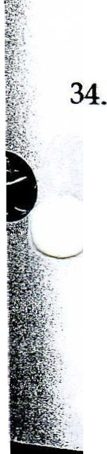C. The normal curves of the adult spine provide greater s. ength than a straight spine.
D. A curved structure has more strength than a straight one of the same size and materials. True ribs:
A. Attach to the cartilage of other ribs
B. Do not attach to the sternum
C. Attach directly to the sternum without cartilage
D. Attach directly to the sternum by means of cartilage

Copyright© 2004 Mosby Inc. All rights reserved.

52 Chapter 6: The Skeletal System

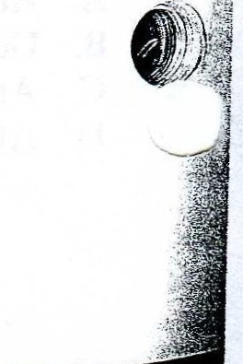

, Ii
.I;

! .:l.
35. The bone that runs along the lateral side of your forearm is the:
A. Humerus
B. tnna
C. Radius
D. Tibia
36. The shinbone is also known as the:
A. Fibula B. Femur C. Tibia D. tnna
37. The bones in the palm of the hand are called:
A. Metatarsals
B. Tarsals
C. Carpals
D. Metacarpals
38. Which one of the following is not a bone of the upper extremity?
A. Radius B. Clavicle C. Humerus D. Ilium
39. The heel bone is known as the:
A. Calcaneus
B. Talus
C. Metatarsal
D. Phalanges
40. The mastoid process is part of the bone.
A. Parietal
B. Temporal C. Occipital D. Frontal
41. When a baby learns to walk, the area of the spine becomes concave.
A. Lumbar B. Thoracic C. Cervical D. Coccyx
42. Which bone is the "funny" bone?
A. Radius
B. T..nna
C. Humerus
D. Carpal
43. There are pairs of true ribs.
A. | 14
B. | 7
c | 5

D.
44. The 27 bones in the wrist and the hand allow for more:
A. Strength B. Dexterity C. Protection
D. Red blood cell production
45. The longest bone in the body is the: A. Tibia
B. Fibula
C. Femur
D. Humerus

Copyright © 2004 Mosby Inc. All rights reserved.

\
. /

Chapter 6: The Skeletal System 53

46. Distally, the articulates with the patella.
A. Femur B. Fibula C. Tibia
D. Humerus
47. The bones form the cheekbones.
A. Mandible B. Palatine C. Maxillary
D. Zygomatic
48. In a child, there are five of these bones. In an adult, they are fused into one.
A. Pelvic
B. Lumbar vertebrae
C. Sacrum
D. Carpals
49. The spinal cord enters the cranium through a large hole (foramen magnum) in the bone.
A. Temporal B. Parietal C. Occipital
D. Sphenoid

Circle the one that does not belong.
50. Cervical Thoracic Coxal Coccyx
51. Pelvic girdle Ankle Wrist Axial
52. Frontal Occipital Maxilla Sphenoid
53. Scapula Pectoral girdle Ribs Clavicle
54. Malleus Vomer Incus Stapes

55. Ulna
-
Ilium
Ischium Pubis

56. Carpal Phalanges Metacarpal Ethmoid
\........_. 57. Ethmoid Parietal Occipital Nasal
58. Anvil Atlas Axis Cervical

. . If you have had difficulty with this section, review pages 127-142.

DIFFERENCES BETWEEN A MAN'S AND A WOMAN'S SKELETON

Choose the correct term.

(A) Male
59.
60.
(B) Female
Funnel-shaped pelvis
Broader-shaped pelvis

61. Osteoporosis occurs more frequently

62.
63.
Larger overall bone structure
Wider pelvic inlet

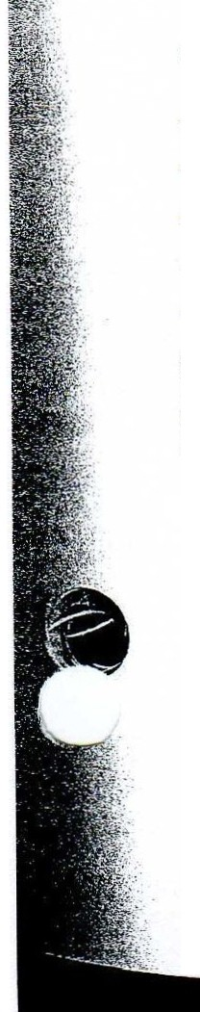
.. If you have had difficulty with this section, review pages 142-143 and page 127.

Copyright © 2004 Mosby Inc. All rights reserved.

54 Chapter 6: The Skeletal System

BONE MARKINGS

From the choices given, match the bone with the identifying marking. There may be more than one marking for some of the bones.

A. Mastoid
B. Pterygoid process C. Foramen magnum D. Sella turcica
E. Mental foramen
F. Conchae
K. Acetabulum
L. Symphysis pubis
M. Ilium
N. Greater trochanter
0. Medial malleolus
P. Calcaneus

! • •
I
G. Xiphoid process
H. Glenoid cavity
I. Olecranon process
}. Ischium

64. Occipital
65. Sternum
66. Coxal
67. Femur
68. Ulna
69. Temporal
70. Tarsals
71. Sphenoid
72. Ethmoid
73. Scapula
74. Tibia
75. Frontal
76. Mandible
Q. Acromion process
R. Frontal sinuses
S. Condyloid process
T. Tibial tuberosity

If you have had difficulty with this section, review pages 131-142.

JOINTS (ARTICULATIONS)

Circle the correct answer.
77. Freely movable joints are (amphiarthroses or diarthroses).
78. The sutures in the skull are (synarthrotic or amphiarthrotic) joints. .
79. All (diarthrotic or amphiarthrotic) joints have a joint capsule, a joint cavity, and a layer of cartilage over the ends of the two joining bones.
80. (Ligaments or tendons) grow out of periosteum and attach two bones together.
81. The (articular cartilage or epiphyseal cartilage) absorbs jolts.
82. Gliding joints are the (least movable or most movable) of the diarthrotic joints.
83. The knee is the (largest or smallest) joint.
84. Hinge joints allow motion in (2 or 4) directions.
85.. The saddle joint at the base of each of our thumbs allows for greater (strength or mobility).
86. When you rotate your head, you are using a (gliding or pivot) joint.

...If you have had difficulty with this section, review pages 143-150.

Copyright© 2004 Mosby Inc. All rights reserved.

Chapter 6: The Skeletal System 55

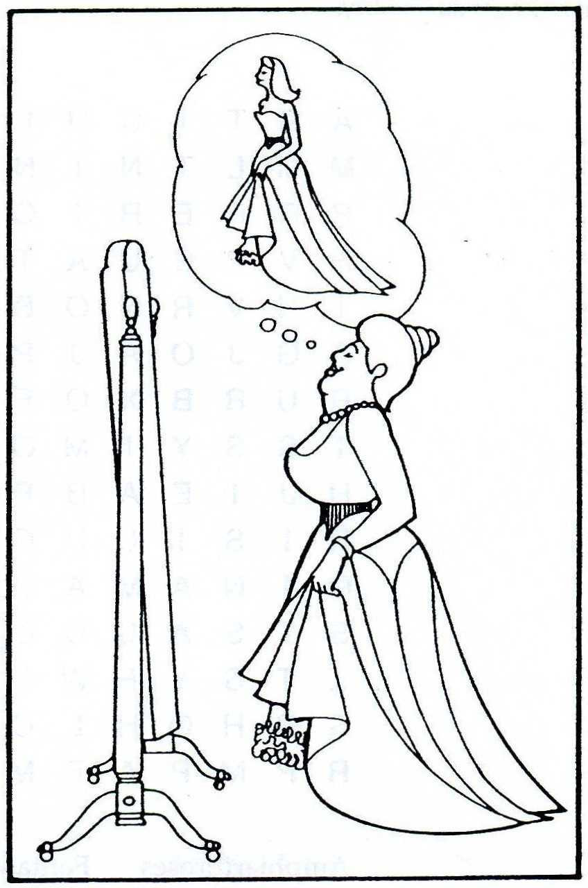UNSCRAMBLE THE BONES

87. ETVERRBAE
[J I I [J [J
88. BPSUI j
K J I r
89. SCALUPA j
I [J I I r
90. IMDBeALnNE b
11

91. APNHGAELS
I I [J I D

92.
Take the circled letters, unscramble them, and fill in the statement.

What the fat lady wore to the ball.

I I I I I IL--11 1'---.1.1

APPLYING WHAT YOU KNOW

93. Mrs. Perine had advanced cancer of the bone. As the disease progressed, Mrs. Perine required several blood transfusions throughout her therapy. One day she asked the doctor to explain the reason for the transfusions. What explanation might the doctor give to Mrs. Perine?

94. Dr. Kennedy, an orthopedic surgeon, called the admissions office of the hospital to advise that within the next hour he would be admitting a patient with an epiphyseal fracture. Without any other information, the patient is assigned to the pediatric ward. What prompted this assignment?

95. Mrs. Van Skiver, age 60, noticed when she went in for her physical examination that she was a half-inch shorter than she had been on her last visit. Dr. Veazey suggested she begin a regimen of dietary supple­ ments of calcium and vitamin D, and he also gave Mrs. Van Skiver a prescription for sex hormone thera­ py. What bone disease did Dr. Veazey suspect?

Copyright© 2004 Mosby Inc. All rights reserved.

96. WORD FIND

Can you find 14 terms from this chapter in the box of letters? Words ma y be spelled top to bottom, bottom to top, right to left , left to right , or diagonally.

A R T c u L A T 0 N N u T M M L T N N G u H J N c G p R p E R 0 s T E u M A N B H v p G u A T B M E 0 p R F G N v R N 0 B 0 F s M H X E R
A G J 0 A J p E T 0 E 0 H T Q R u R B X 0 E E c A s G I s B T s s y M 0 Q N u 0 0 L X Q H J I E A B p u N Q L E Q K s
R s L u c I L A N A c X R
0 I N A M A s Q M A Q K E c T s T s A L c 0 E T s 0 u 0 G E T s y F w L N M p u F N u F s B H Q H L 0 u s A R X T v R p M p A F M G X K 0 s L G A

tc
Amphiarthroses  Articulation | Fontanels  Hemopoiesis | Osteoclasts  Periosteum
Axial  Canaliculi | Lacunae  Lamella | Sinus  Trabeculae
Compact | Osteoblasts

i ' '

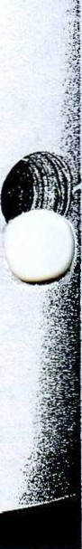:! ·: .

DID YOU KNOW?

The bones of the hands and feet make up more than half of the total 206 bones of the body. Approximately 25 million Americans have osteoporosis. Four out of five are women.
The bones of the middle ear are mature at birth.

Copyright © 2004 Mosby Inc. All rights reserved.

- - - - -- - -- - - - -

Chapter 6: The SkeletalSystem 57

SKELETAL SYSTEM

Fill in the crossword puzzle.

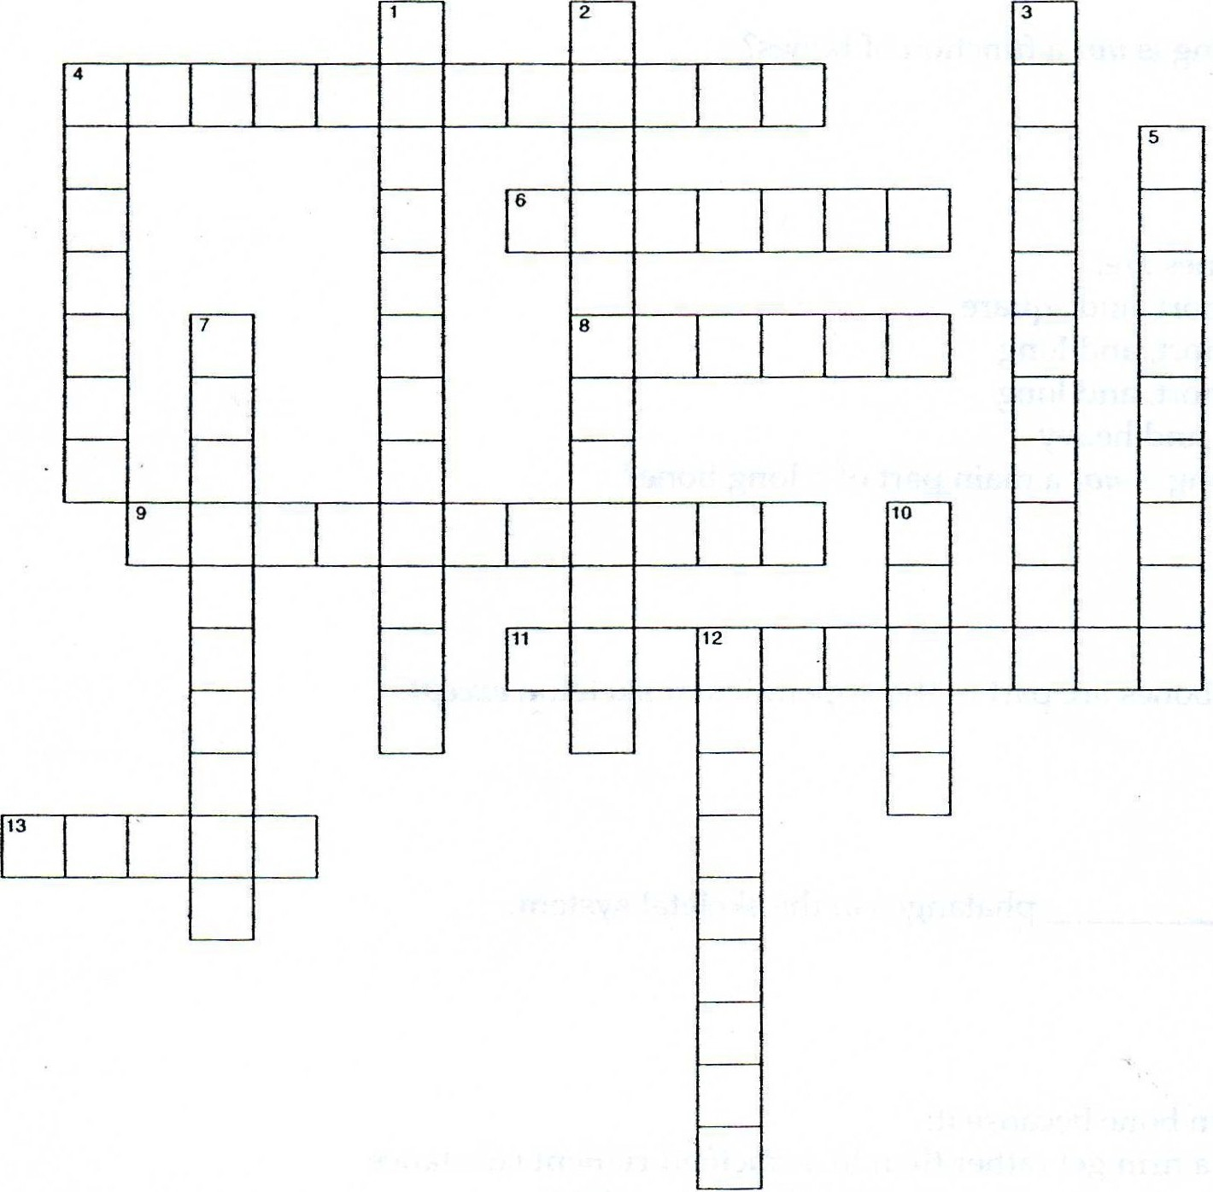

Across
4. Cartilage cells
6. Spaces in bones where osteocytes are found
8. Chest
9. Freely movable joints
11. Process of blood cell formation
13. Space inside cranial bone
Down
1. Joint
2. Suture joints ' ·
3. Bone absorbing cells
4. Type of bone
5. Ends of long bones
7. Covers long bone except at its joint surfaces
10. Division of skeleton
12. Bone cell

Copyright © 2004 Mosby Inc. All rights reserved.

I
il
!1
!I

'I I
' l
I i
:;.·!' Ii
:: i I
!: r·i
I '
;' I '
. l !
l
... j
. i i
!
i '
CHECK YOUR KNOWLEDGE Multiple Choice
Circle the correct answer.
1. Which of the following is not a function of bones?
A. Communication
B. Storage
C Hemopoiesis
D. Protection
2. The four types of bones are:
A. Flat, irregular, short, and square
B. Flat, cartilage, short, and long C Flatirregular, short, and long D. Small, long, flat, and heavy
3. Which of the following is not a main part of a long bone?
A. Malleus
B. Epiphyses C. Periosteum D. Diaphysis
4. Ali of the following bones are part of the appendicular skeleton except:
A. Shoulder
B. Hip C. Chest D. Feet
5. There are a total of phalanges in the skeletal system.
A. 28
B. 60
c. 56
D. 72
6. Cartilage differs from bone because it:
A. Is embedded in a firm gel rather than in a calcified cement substance
B. Has the flexibility of a firm plastic rather than being rigid
C. Rebuilds itself very slowly after injury
D. All of the above
7. Whith of the following is not a paranasal sinus?
A. Frontal
B. Ethmoid
C Lambdoidal
D. Sphenoid
8. The last two ribs:
A. Attach directly to the sternum B. Are attached to costal cartilage C. Are referred to as "floating ribs" D. None of the above
9. In an infant, each coxal bone consists of three separate bones. These bones are the: A. ilium, ischium, and coccyx
B. Ischium, pubis, and tuberosity C. Pubis, tuberosity, and coccyx D. ilium, ischium, and pubis
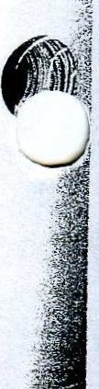10. An example of a synarthrotic joint is: A. A cranial suture
B. The hip joint
C. The shoulder joint
D. Thespine

Copyright© 2004 Mosby Inc. All rights reserved.

Matching

Select the most correct answer from column B for each statement in column A. (Only one answer is correct.)

ColumnA Column B
-- 11. Articulation A. "Funny bon
12. Medullary cavity B. Yellow bone marrow
13. Osteons c. Immovable
14. Incus D. Circumduct
15. Sternum E. Manubrium
16. Zygomatic F. Flexion
17. Olecranon process G. Joint
18. Synarthroses H. Cheekbone
19. Hinge joint I. Haversian system
20. Thumb joint J. Middle ear

LONGITUDINAL SECTION OF LONG BONE

1.
}a

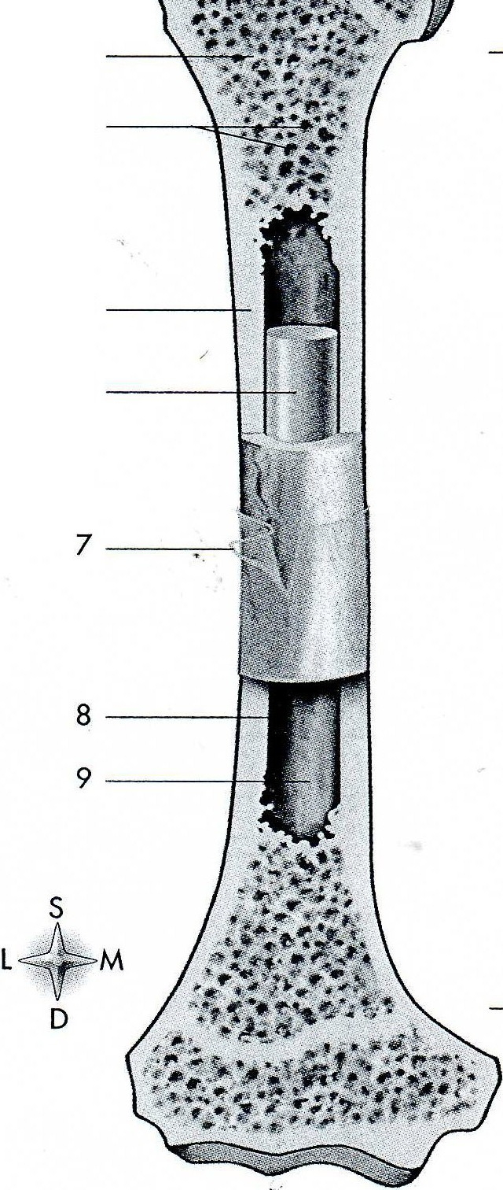2. 1 .

3.
2
4.

5. 3
6. 4
7.

8.

9.
5
10.
11. 6

11

Copyright© 2004 Mosby Inc. All rights reserved.

ANTERIOR VIEW OF SKELETON

1.
\... .- | 2.
 | 3.
 | 4.
 | 5.
 | 6.
 | 7.
 | 8.
 | 9.
 | 10.
 | 11.
 | 12.
 | 13.
 | 14.
 | 15.
 | 16.
 | 17.
 | 18.
 | 19.
 | 20.
 | 21.
 | 22.
 | 23.
 | 24.
 | 25.
 | 26.
 | 27.
 | 28.
 | 29.
 | 30.

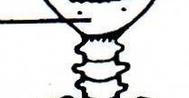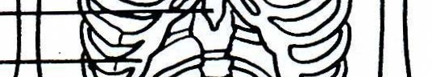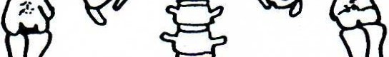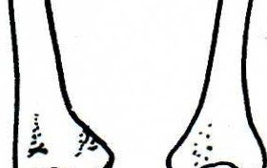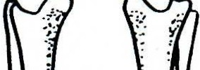2

3

4
5

10

11
12

13

14

15

16

17
6
18
7 19
8 20
9 21
22
23

24

25

26
27
'

Copyright © 2004 Mosby Inc. All rights reserved.
28
30 29

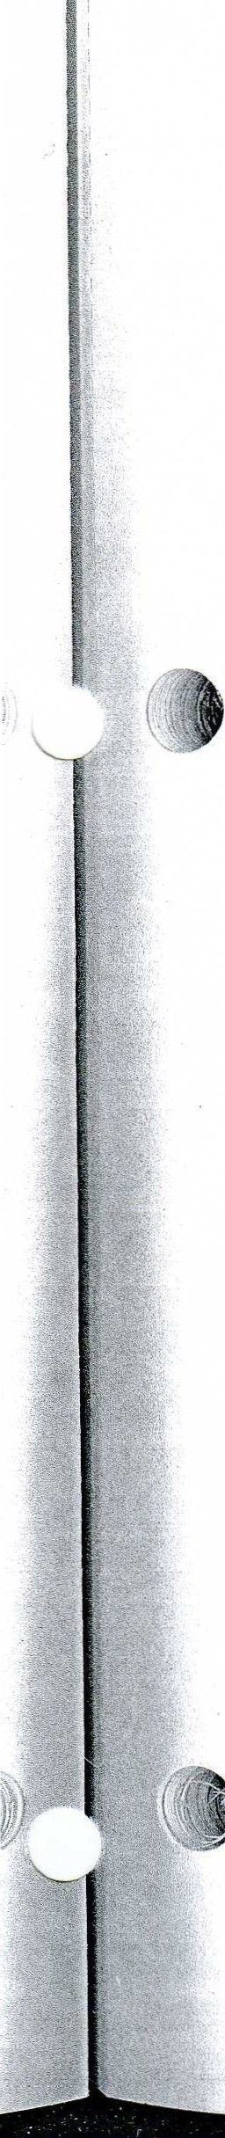

POSTERIOR VIEW OF SKELETON

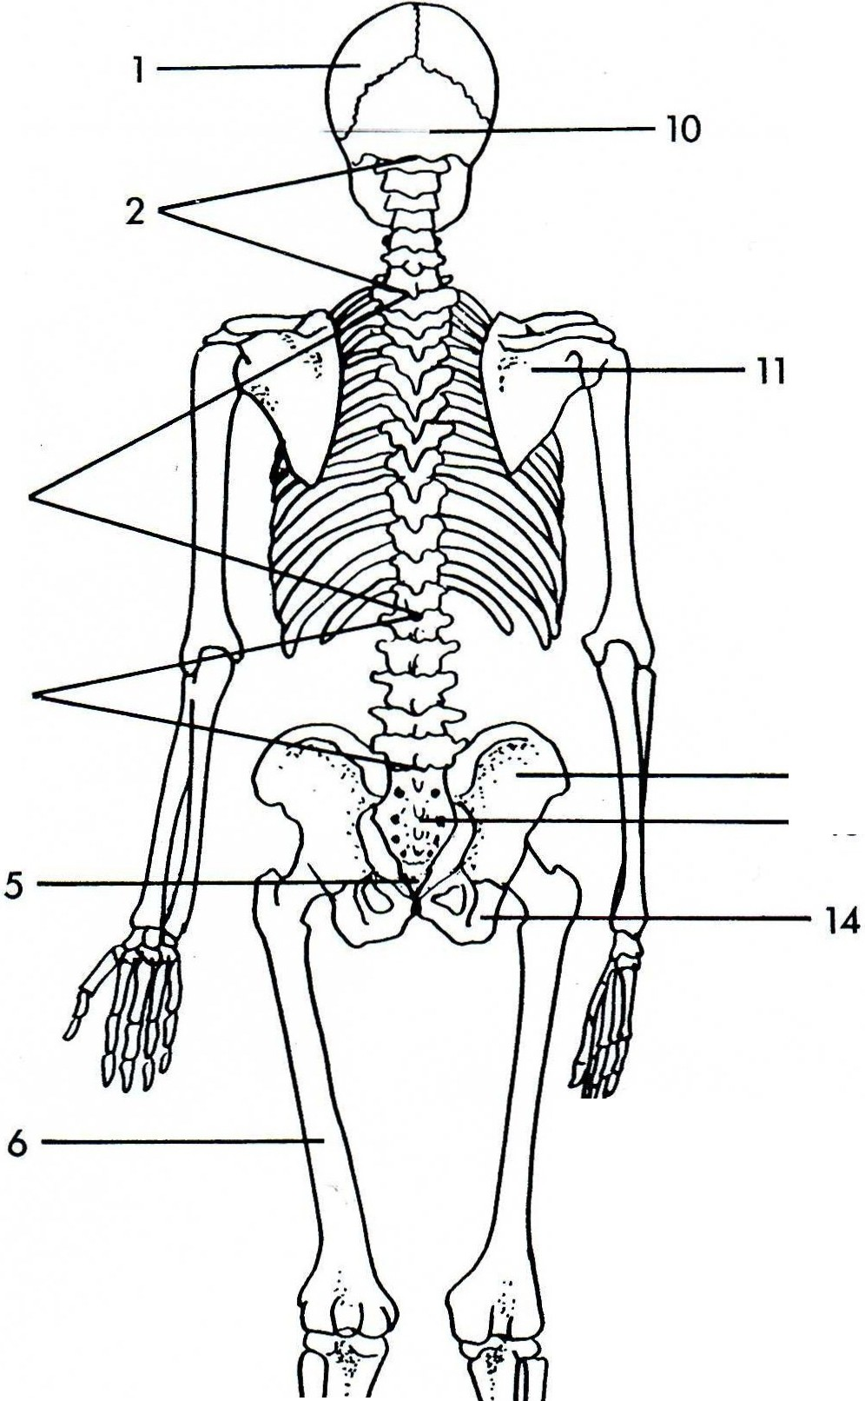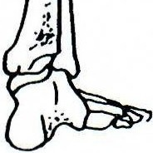3
1.
2.
3.
4.
5.
6.
7.
8.
9.
10.
11.
12.
13.
14.

4

-+--+-+----12
--H----13

7------t

8-----+H-

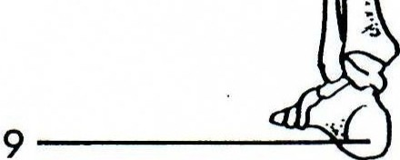

Copyright © 2004 Mosby Inc. All rights reserved.

SKULL VIEWED FROM THE RIGHT SIDE

9

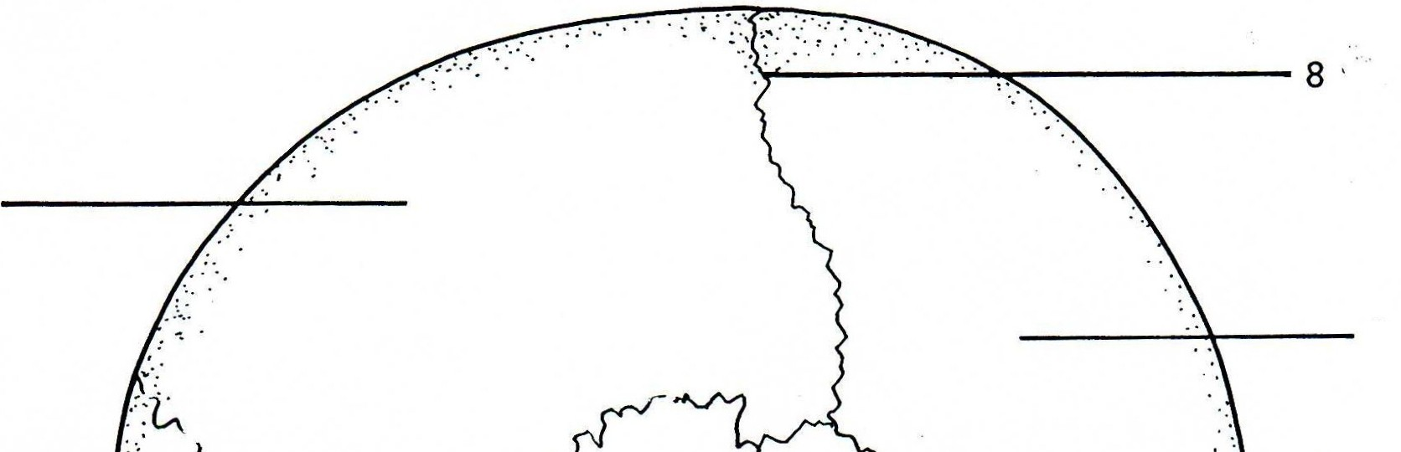2 10

3 11

12

4
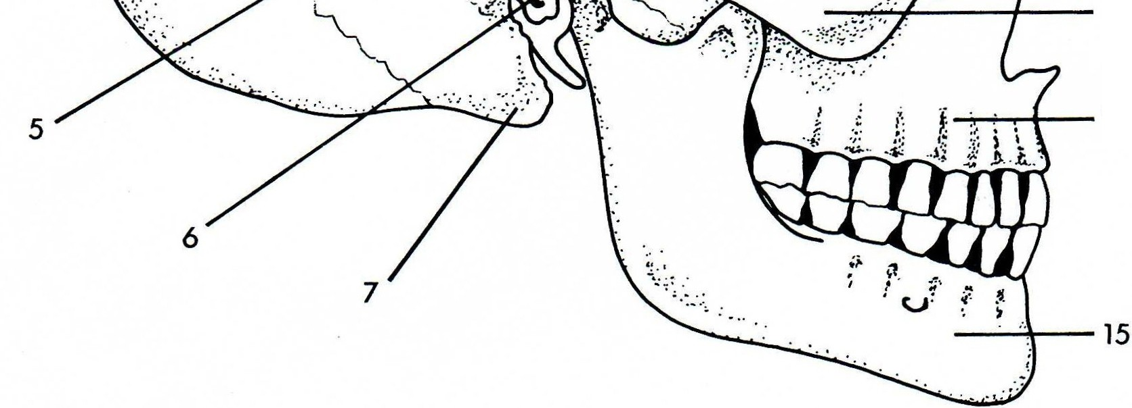13
14 '

.
1. |  | 9.
2. |  | 10.
3. |  | 11.
4. |  | 12.
5. |  | 13.
6. |  | 14.
7. |  | 15.
\.. .,.

Copyright © 2004 Mosby Inc. All rights reserved.

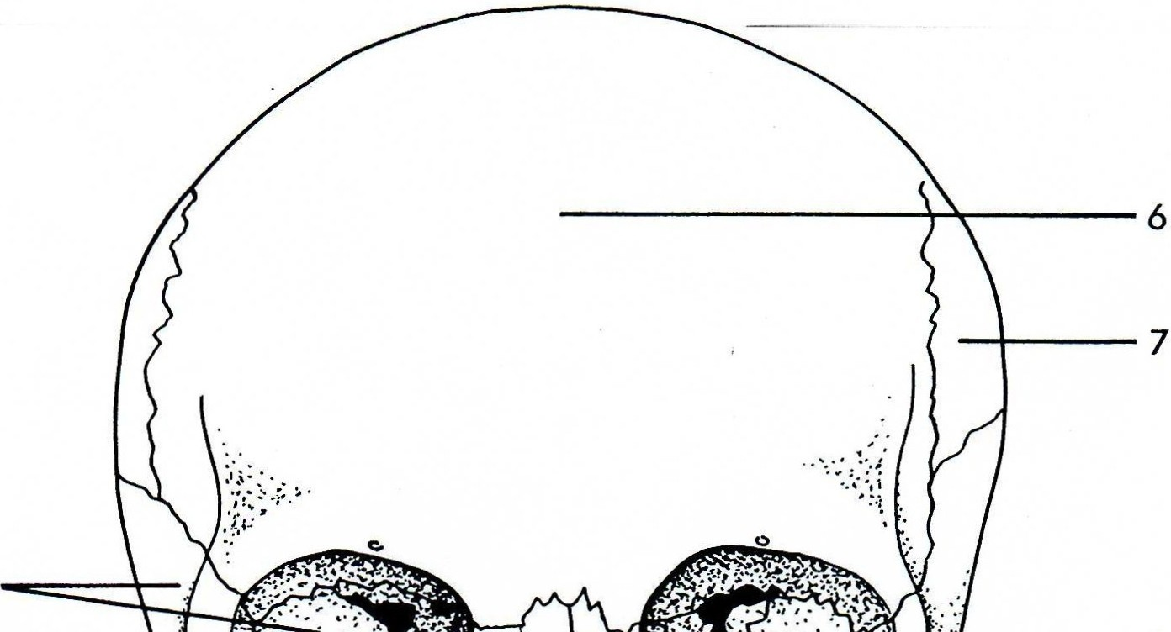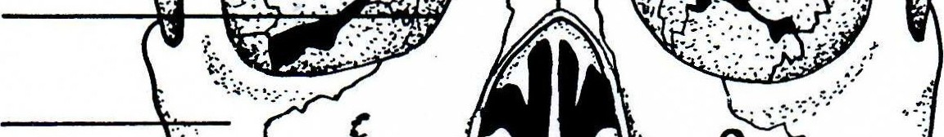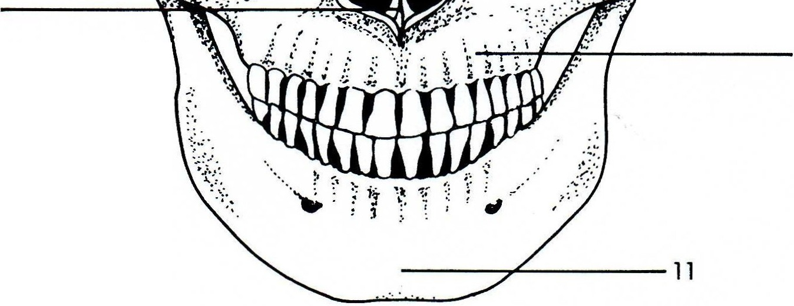SKULL VIEWED FROM THE FRONT

2 8
3

4
9

, , 5
1-
10

1. |  | 7.
2. |  | 8.
3. |  | 9.
4. |  | 10.
5. |  | 11.
6.
'f.t
-
-¥'"

Copyright© 2004 Mosby Inc. All rights reserved.

-

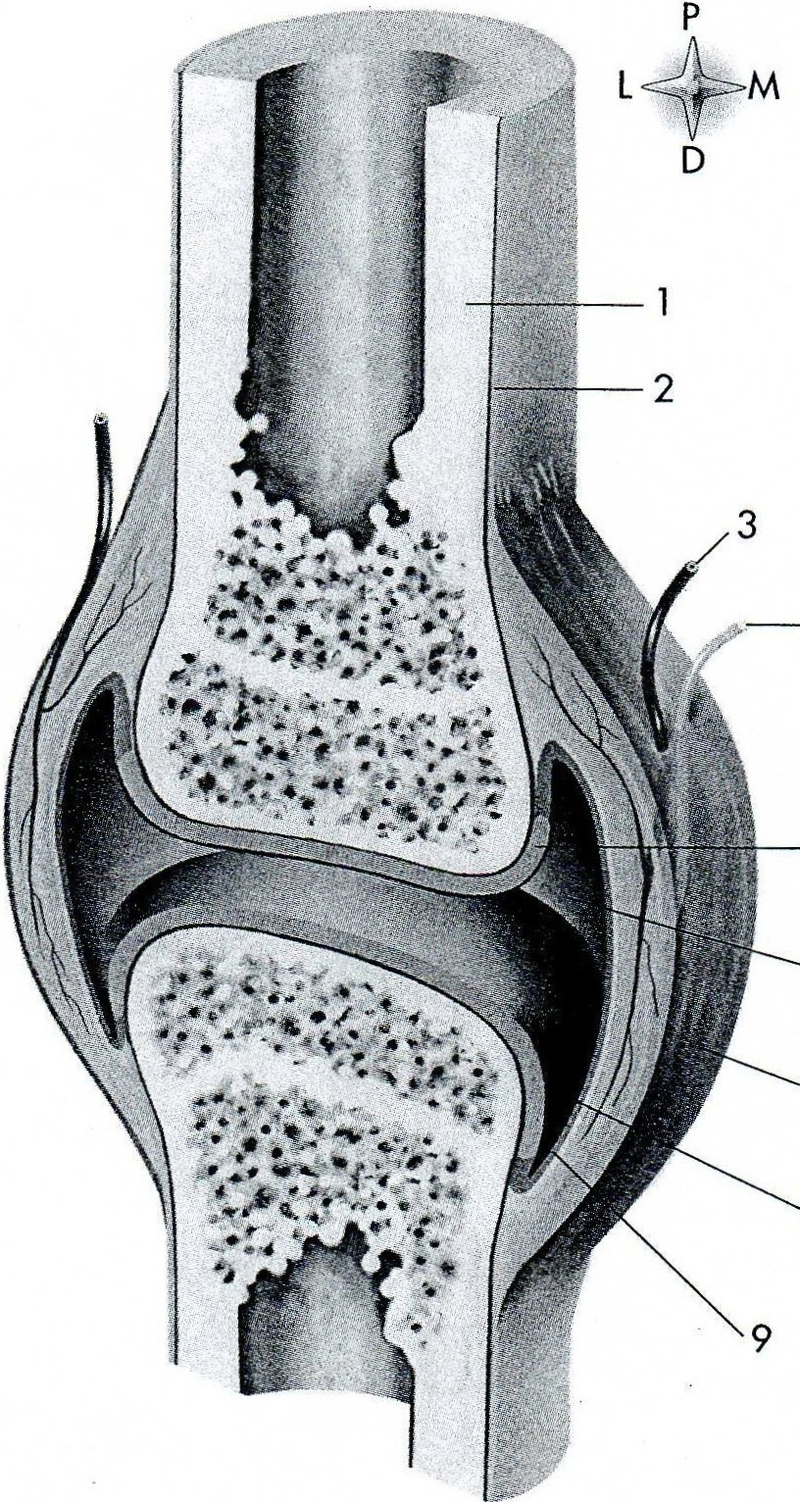4

5

6

7

8

1. |  | 6.
2. |  | 7.
3. |  | 8.
4. |  | 9.
5.

Copyrigh t © 2004 Mosby Inc. All rights reserved.

