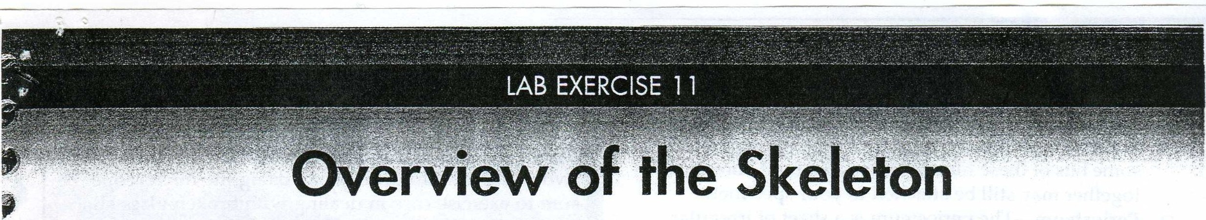

his exercise is the first of several concerning the skeletnl
T
., syst em. The skeletal sy st em's major organs are the bones
and ligaments. Ligaments are simplv cords of regular dense
'I fibrous tissue that bind the bones to on e another. Bones are
more complex in their structure, so we wilJ spend some tim e
investigating the nature of a typical bone. Before we move
' on to a detailed study of all the bones of th e skeleton, we will survey the basic plan of the skeleton.

'p Investigation of the gross and microscopi c structu re of the typical bone and of the basic skeleta l plan will be good
preparation for the exercises that follow.
t
Before you begin
J 0 Read the appropriate chapter in your tex tbook.

Set your lea rning goals. When you finish this exercise,
'0 you should be able to:
A. Bone types
The 206 bones in the standard human skeleton can be cl assi­ fied by their sha pes. The best ,,vay to Jearn this classification sch eme is by tryin g to classify the bones yourself, as outlined in the following steps:

0 1 Unpack the bones of a disa rticulat ed (taken apart) human skeleton and sprea d the bones over your work place.

0 2 DiYid e the group of bones into four piles, according to the categories given here. Do not use books or other aids to help you.
::J long bones are cylindrical bones that are longer than the\' are ,,v id e.
:J Short bones are a s lon g as they are wide, som etimes h a vin g a n almost cu boida l sha pe.
Q Flat bones a rise when bone tissue inv ades and hard­

'
-i-'

:J describe the organs oi the skeletal system
:J describe th e gross and microscopic structure of bone tissu e
Q list the primary functions of the skel e tal system
Q outline the organization of the skel etal system

en s fibrou s membranes, so they are shee tlike in shape. They a re usuall y curved, rather than absolutely flat.
:J ]rregu]ar bones d on 't quite fit a n y of the other cate­
gories beca use of the complexity of th eir shapes.

0 Prepare your materials:
:.:::t microscope
o prepared microslid es:
compact bone (ground bone) cs. cancellous bone
epiphyseal plate c.s.
Q human skeleton (disarticulated)
o human skeleton (articulated)
Q long bone (fresh, whole)
• o whole long bone (fresh, J.s.)
0 Read the directions and sa fety tips for this exercise cnre-
J y before sta rting any procedure.
full
-
•

The concep ts of this exercise will be easier to understand if you briefly review the microscopic organization of bone tissue presented in Exercise 8.
,

9

)
\.._....
0 3 Compare your results to th e results of others in your
l ab section. Does everyone agree?

B. Gross structure of a bone
All bones have the same genera l s tructural pattern . Some bones have more "optiona l features" than other bones. The long bone is often u sed as a genera l specimen for study because it has all the features tha t any bone can have (Figure 11-1 ).

8Jr?&'fi'V r?am ll!JL'i
Because fresh animal tissues at room temperature can har­
bor dangerous bacterial colonies, specimens should only be handled when wearing disposable, nonporous gloves.

0 1 Obtain fresh long bone speci m ens from a large ani­ mal. One should be whole (uncut), and the other cu t along its lon g axis (l ongitudinal section, l.s.).

0 2 Ex<1mine the ex ternal aspec t of a whole bon e. Find the features described.

j
Copnight 'L• 2 03 lw Mosby, In c. A ll rights reserwd. 99

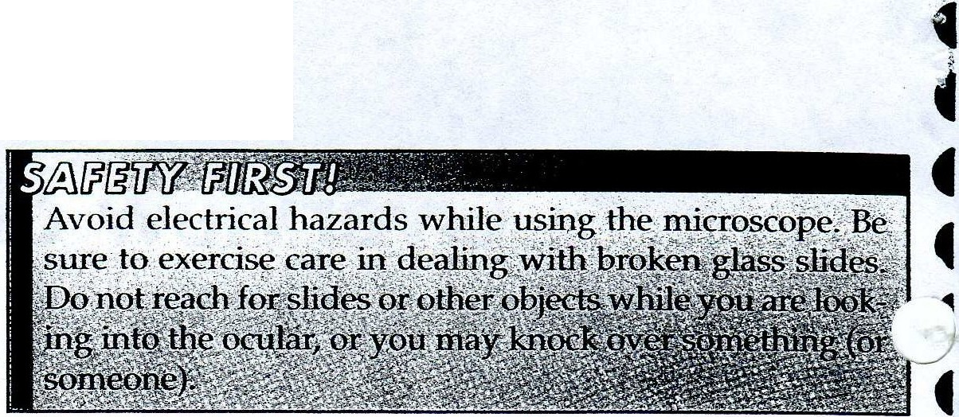100 lab Exercise 11 • Overview of the Skeleton

o Ligament-Although actually a separate organ, some bits of these fibrous straps that hold bones together may still be attached to your specimen.
o Periosteum-The periosteum is a sheet of irregular
dense fibrous connective tissue continuous with the ligaments. It covers the shaft and part of the heads of a long bone. Try to scrape some of the periosteum away from the underlying bone. How strongly is it attached?
o Articular cartilage- The articular cartilage is a
smooth cap of hyaline cartilage found where the bone articulates (forms a joint) with another bone. Joints, or connections between bones, are often mov­ able. Which function of the skeletal system benefits by the presence of movable joints?
o Diaphysis-The diaphysis is the whole central shaft
of the long bone. Only the external part of the shaft, made of solid bone tissue, is visible from the external aspect. For what skeletal functions is the hard she]]
of the diaphysis specialized?
o Epiphysis-The epiphyses are the "heads" of a long bone, one proximal to the diaphysis, one distal. Only the external portions are visible in a whole specimen.

0 3 Use the sectioned bone specimen to identify the structures listed .
0 Medu11ary cavity-The medullary cavity, as its
name implies, is a space within the center of the dia­ physis. The walls surrounding the space are made of both cancellous and compact bone. In the adult, the cavity generally contains yellow bone marrow, which
is a mass of fatty tissue. What is the purpose of yel­
low marrow?
o Endosteum-The endosteum is a thin epithelial membrane that lines the medullary cavity.
0 CancelJous bone-The epiphyses, like diaphyses, have a compact bone cortex, but the medulla is often different. The inside of each epiphysis has cancel­ lous, or spongy, bone. The soft tissue in the spaces of the cancellous bone is often red bone marrow, which produces blood cells.

C. Microscopic structure of a bone
The microscopic structure of the long bone reflects the gen­ eral nature of any type of bone (Figure 11-2). As you learned in Exercise 8, there are two basic types of bone tissue within a bone organ: compact bone and cance11ous bone. In this exercise, you will build on what you learned about these bone tissue types. Then you will be able to integrate this information with what you already know about the gross structure of bone so that you can see "the big picture" of bone structure and function.

0 1 Compact bone-Compact bone is found mainly in the hard, outer shell of a bone organ. Compact bone tissue is formed by solid, cylindrical units called osteons packed tightly together. The osteon, or Haversian sys-

tern, consists of multiple concentric layers of hard bone matrix, with cells sandwiched between each layer. This bone matrix is made up of collagen fibers encrusted with crystals of a calcium-containing mineral called apatite. Each layer of bone matrix is a lamella (plural lamellae). Osteocytes are literally trapped within lacu­ nae between the lamellae. The osteocytes were once active osteoblasts but have trapped themselves in the

solid matrix they formed. Notice in Figure 11-3 that the periosteum that surrounds each bone is made up of an 4
inner layer that contains active osteoblasts and an
outer layer of dense fibrous connective tissue. The 4
lamellae are centered around the central (Haversian)
canal's blood vessels. There are also transverse canals f
connecting the central canals of adjacent osteons.
c
These transverse canals are called transverse or
Volkmann's canals. They are also sometimes called perforating canals.The osteocytes trapped within
c
lacunae transport materials to and from the canal by 4
way of tiny canaliculi ("small canals") that connect the osteocytes to each other and to the canal. Observe a f
prepared slide of ground bone (compact bone) and trr
to identify as many features as possible. --A

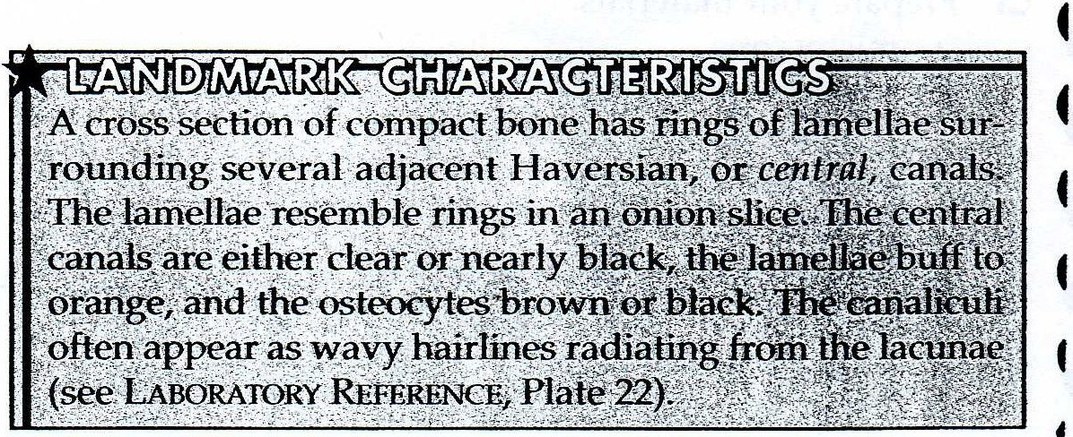

0 2 Cancellous bone and hematopoietic tissue­ Cancellous bone is found in the inner portions of a bone organ. Cancellous bone is easily identified by its open, latticelike structure. Thin plates of bone matrix, with a scattering of osteocytes trapped within lacunae, form structural beams that have great strength despite the open spaces. These
branching beams of hard bone are called trabeculae. Because cancellous bone has open spaces, it is some­ times called spongy bone.This name can be mis­ leading because one might think spongy bone is as soft as a bath sponge; it is not soft at all because it has hard trabeculae. The spaces are filled with hematopoietic or myeloid tissue, a special type of bloo

Copyright© 2003 by Mosby, Inc All rights reserved.

....
.....
...
-.i.ll.

II COLORING EXERCISE
Using colored pens or pencils, shade in the figure and accompanying labels in
contrasting colors of your choice as indicated by the red numerals.

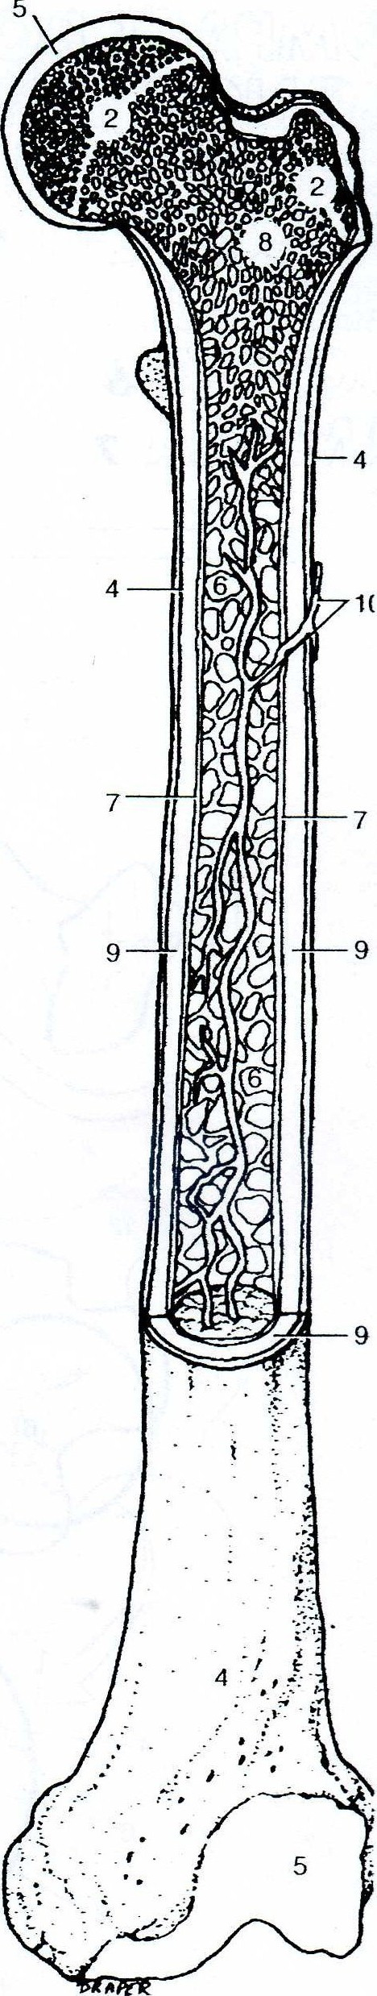Long Bone

Gross Structure
rnCo=DuillDill

...
..
1
rnCo=Duillrn&O:, O:&vrn 2
@O&C=DuillDill 3
rnD@illvrn M 4
&VOMO:& &VDO:&®rn s
rn@MD:,O:&u &WDUV6
rn[K!J @@illvrn M

....
....
.....
...
...
...
..
...
7
CS&[K!JCS rn D:,D:,@Mill [B@[K!J rn s cs@ &v [B@[K!Jrn 9 [1)[1,@@@ wrnillillrnO:, 1o

,....
- Figure 11-1 Structures of the long bone.

Copyright © 2003 by Mosby, Inc. All rights reserved.

leOLORING EXERCISE
;ing colored pens or pencils, shade in the figure and accompanying labels in
ntrasting colors of your choice as indicated by the red numerals.

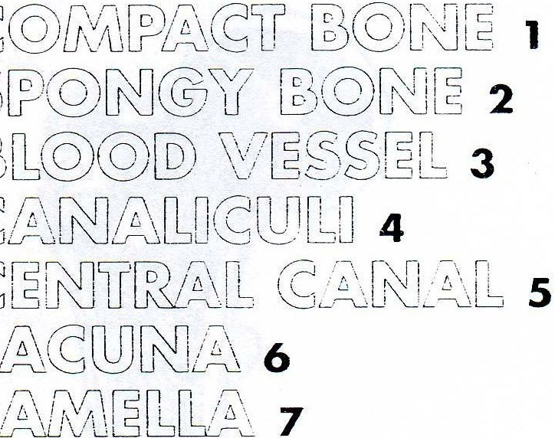one Tissue

( 2J L0C<l(
i:Q:L:);=r (Q 1o

9(J
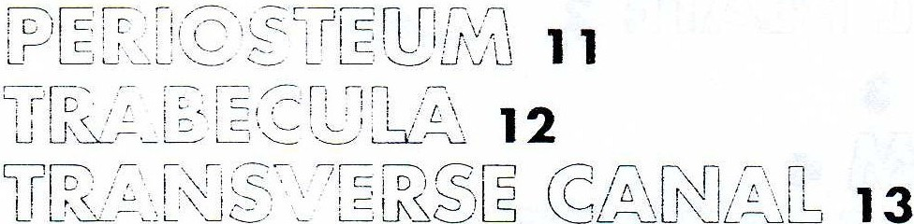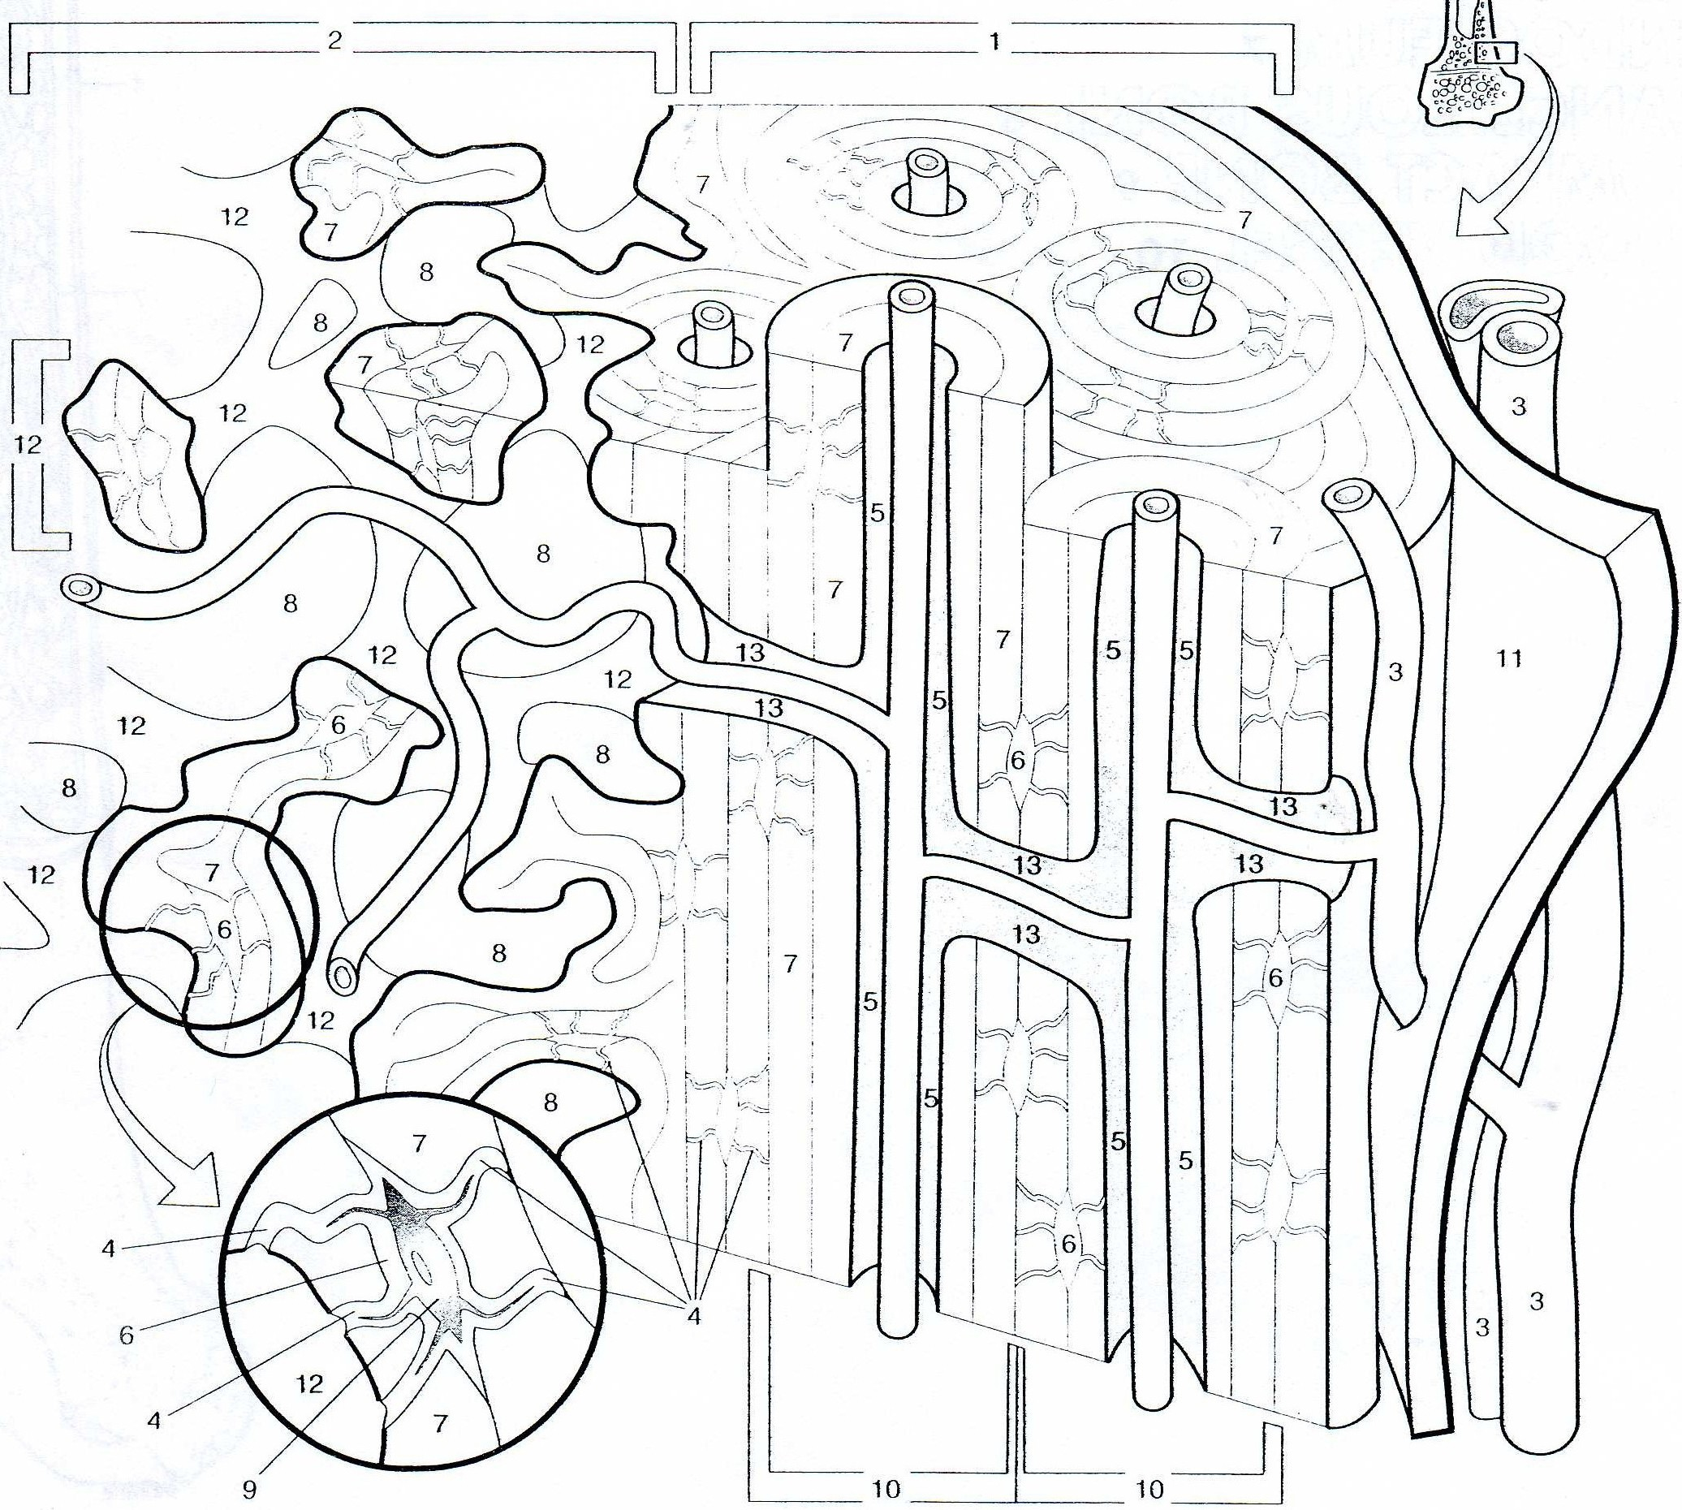•
•
4
t
t•
•
•

Figure 11-2 Microscopic structure of bone.
Copyright © 2003 by Mosbv, Inc. All rights reserved.

Anatomy & Physiology laboratory Manual
103

Osteocytes
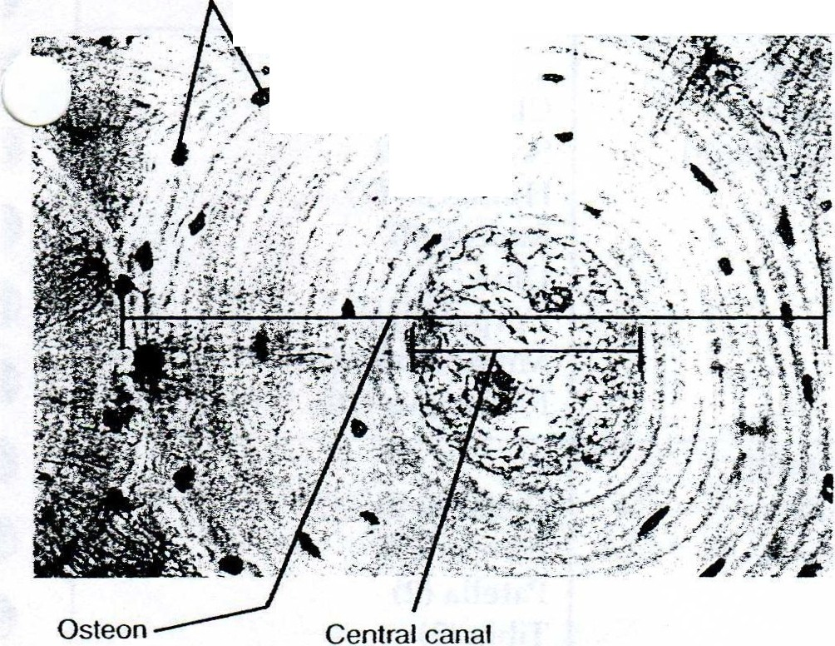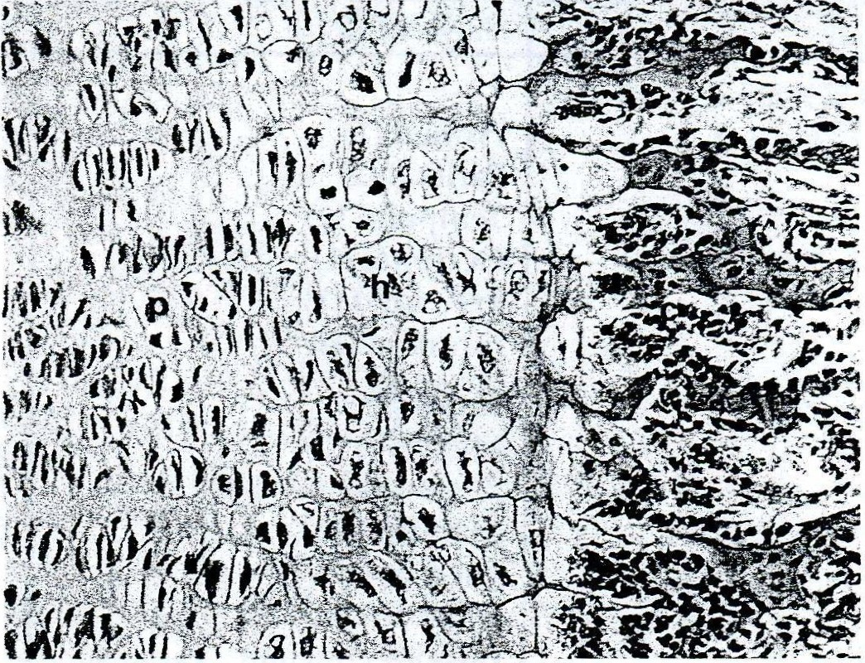within lacunae Lamella

'}/fc:•
-· -·

igure 11-3 Compact bone (ground bone) in cross section.
,_igh power.

Cancellous bone is distinguished by its rather disorgan­ ized array of trabecular beams of bone surrounded by myeloid tissue. The bone pieces may look like slivers of compact bone, with lamellae that often do not form com­ plete circles. The myeloid tissue is a scattering of blood cells, which appear as tiny, dark circl es. Myeloid
'' ' matopoietic) tissue may also have a netlike formation-
\ .,;ery thin collagen fibers called reticular fibers. In some
preparations, the bone tissue is pink, and the myeloid cells are dark red (see LABORATORY REFERENCE, Plate 23).

tissue that produces new blood cells. Hematopoietic tissue is also called red bone marrow.

0 3 Epiphyseal plate- Until a long bone has stopped growing in length, a layer of carti l age ca lled the epi-

. The epiphys al plate shown in _Figure 11-4 is made up of fot1r regions;adfregion, in tum, is made of several layers of cells. The layr Closest to the epiphysis (left of figure) is not

changing or growing, so the cells are said to be at rest. The letterp m the figure marks the zone of proliferation, which in­
dudes cells t.indergoing mitotic division. This is where the
· plate becomes thicker. The letter h in the figure marks the zone of hypertrophy, where older, enlarged cells degenerate be­ fore calcification. Towarq the right of the zone of calcification, marked_ c in the figure, new cancellous bone can be seen. Typically, the epiphyseal plate is seen as a region of hyaline rartilage separated from a region of cancellous bone by a re- m of <fe&enerating chondrocytes (cartilage cells) in lacu­
ae that seem to be "stacked" in roughly parallel rows.

Copyright © 2003 by Mosby, lnc. All rights reserved .
Figure 11-4 Detail of epiphyseal plate. Epiphyseal plate car­ tilage at left transforms into zones of proliferating (p) chon­ drocytes and hypertrophic (h) or degenerating cells with pri­ mary ossification occurring on their calcified (c) remnants. Newly formed bone appears at right (SO X ).

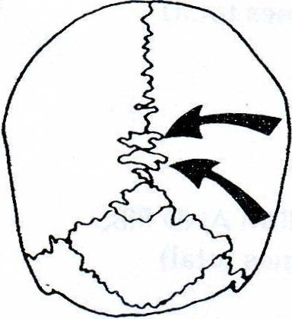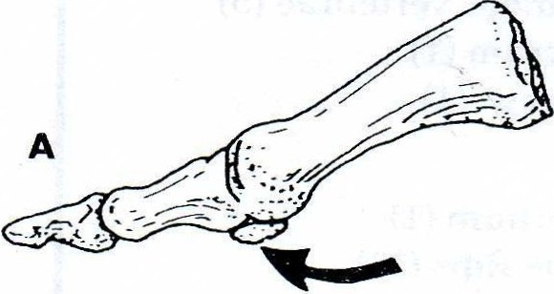 8
Figure 11-5 A, Sesamoid bone at the base of the thumb.
B, Wormian bones along a suture joint.

physeal plate remains between each epiphysis and the diaphysis (Figure 11-4). During periods of growth, prolif eration of epiphyseal cartilage cells brings about a thickening of this layer. Ossification (bone formation) of the additional cartilage nearest the diaphysis then follows; that is, osteoblasts make
new bone matrix. As a result of this process, the bone·
becomes longer.

D. The plan of the skeleton
The usual number given for bones in the human skeleton is
206. This is by no means the absolute exact number, however. Most people have more bones, but each person has different types, locations, and numbers of "extra" bones (Figure 11-5). Some people may be missing a bone or two. In this activity, you will examine both the standard 206 bones and the ex tra bones that may be present (Table 11-1).

'4
04 Lab Exercise 1 1 • Overview of the Skeleton
t
•4

SKULL (28 BONES TOTAL)
:=ranium (8 bones)

Face (14 bones)

Ear bones (6 bones)

HYOID BONE ( 1 ) SPINAL COLUMN
[ 26 bones total)

STERNUM AND RIBS
(25 bones total)

Frontal (1) Parietal (2) Temporal (2) Occipital (1) Sphenoid (1) Ethmoid (1)

Nasal (2) Maxillary (2) Zygomatic (malar) (2) Mandible (1)
Lacrimal (2) Palatine (2) Inferior conchae (turbinates) (2) Vomer (1)

Malleus (hammer) (2) Incus (anvil) (2) Stapes (stirrup) (2)

Cervical vertebrae (7) Thoracic vertebrae (12) Lumbar vertebrae (5) Sacrum (1)
Coccyx (1)

Sternum (1) True Ribs (14) False Ribs (10)
UPPER EXTREMITIES (including shoulder girdle) (64 bones total)

LOWER EXTREMITIES
(62 bones total)

Clavicle (2) Scapula (2) Humerus (2) Radius (2)
'1
s (10) t•
Ulna (2)
Carpals (16) Metacarpal Phalanges (28)

Coxal bones (2) Femur (2) Patella (2)
•
Tibia (2)
Fibula (2) Tarsals (14) Metatarsals (10) Phalanges (28)
t
t
t
•

•
t
t

•
•

:xcludi ng variable sesamoid and wormian bones.

1 Obtain an articulated (connected) human skeleton.

2 The standard axial skeleton consists of 80 bones that form the central axis of the skeleton (Figure 11-
6). These 80 bones include 28 skull bones, 1 unat­ tached bone in the throat, 26 vertebrae, and 25 rib cage bones. Locate the bones of the axial skeleton in your specimen. Do not worry about learning the names of individual bones now. That wil1 come

)£fl 'fil! [}ar:lg).f!a
Be cautious when handling the articulated skeleton. The
bones or mounting hardware may become loose and fall from the support frame, inj ring you or your Jab mates.
later. For now, concentrate on "the big picture" of
skeletal organization.

0 3 Locate the bones of the appendicular skeleton in your specimen. The appendicular skeleton, compris­ ing the 126 nonaxial bones, includes the bones of the appendages, or extremities (arms and legs). Sixty­ four of these bones are in the upper extremities (shoul­ ders and arms). Sixty-two bones are in the lower extremities (hips and legs).
0 | 4 | Ask your lab instructor if there are any extra stan­
 |  | dard bones or any standard bones missing in your
specimen. What difficulties could such differences
have caused the individual during life?

•
•••
•

--J

Copyright © 2003 by M osbv, Inc. All ri ght s reserved.

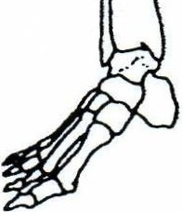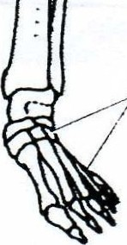
COLORING EXERCISE
Using colored pens or pencils, shade in the figure and accompanying labels in contra sting colors of your choice as indicated by the red numerals.

verview of the Skeleton
D&[b rn[brnu@ | 1
L rn@D M[b& | [brnu@ | 2

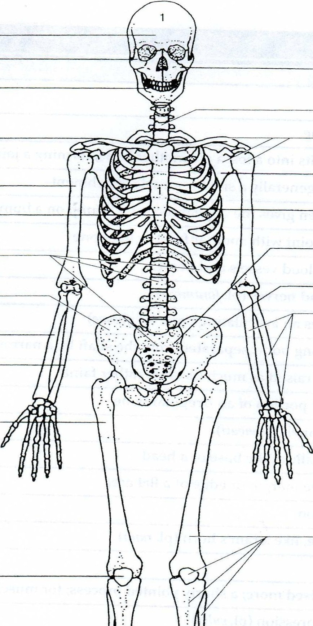

3

4
14
5

6 2

15
7

8 16

17

18
2
2
9

10

11
,., _
.iiJ,j
2

12

JJ
41 13
19
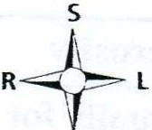.-41.
2

Figure 11-6 Bones of the human skeleton.

106 Lob Exercise l1 • Overview of the Skeleton

0 5 Determine whether your specimen has any of the ex tra bone types typically found in skeletons (see Figure 11-5):
o Sesamoid bones are so ca lled because they
resemble sesame seeds: tiny rounded specks. Sesamoid bones are often found within tendons of the hand and foot.
o Wormian bones, also called s utural bones, are flat
bones that form in the sutures (joints) between the cranial bones of the skull.
E. Bone markings and features
As you have already observed on your specimen, bones dO
not generally have a smooth surface. There are many 1 bumps, holes, and projections on the bones of the human skeleton. These bone marking s are named with terms that
describe their shape and location. As a preview to the next ..._./
few exercises, review the terms used to name bone mark- ings listed in Table 11-2.

Angle A corner

Body The main portion of a bone

Condyle Rounded bump; usua1ly fits into a fossa on another bone, forming a joint

Crest Moderately raised ridge; generally a site for muscle attachment

Epicondyle Bump near a condyle; often gives the appearance of a"bump on a bump"; for a muscJe attachment

Facet Flat surface that forms a joint with another facet or flat bone

Fissure Long, cracklike hole for blood vessels and nerves

Foramen Round hole for vessels and nerves (pl. foramina)

Fossa Depression; often receives an articulating bone (pl. fossae)

Head Distinct epiphysis on a long bone, separated from the shaft by a narrowed portion (or neck) Line Similar to a crest but not raised as much (is often rather faint)
Margin Edge of a flat bone or flat portion of an irregular bone

Meatus Tubelike opening or channel (pl. meah)

Neck A narrowed portion, usually at the base of a head

Notch A V-like depression in the margin or edge of a flat area

Process A raised area or projection

Ramus Curved portion of a bone, like a ram's horn (pl. rami)

Sinus Cavity within a bone

Spine Similar to a crest but raised more; a sharp, pointed process; for muscle attachment

Sulcus Groove or elongated depression (pl. sulci)

Trochanter Large bump for muscJe attachment (larger than tubercle or tuberosity) Tubercle Sma1ler version of a tuberosity
Tuberosity Oblong, raised bump, usually for muscle attachment

Copvright © 2003 by Mosbv, lnc. All right s reserved.

Name: _ Date: _ Section: _

LAB REPORT 11

Overview of the Skeleton

M ulti ple Choice

1.

l 2.

j 3.

4.
J
5.
J
6.
J
Figure l l -6
J
J I
1.
Multiple Choice (only one response is correct)

1. The inner lining of the medullary cavity is a. made of compact bone
b. called the endosteum c. called the periosteum d. a and care correct

2. Which of these tissues is present in a typical long bone?
a. blood tissue
b. cancellous bone
c. compact bone
d . dense fibrous tissue
e. hyaline cartilage
f. all of the above

2.
J· 3.
J 4 _

.J; 5_

._/ 6.
w 7.
..:J 8.
9.
.J
10.
i.J
11.

3. ln the coloring figure of the long bone, the epiplwseal plat e is shown . What is the reason for its presence?
a . it is scar tissue from a previou s fracture
b. it is an area of growth between the epiphysis and di a physis during bone d evelopment
c. it is callous tissue from overuse of the bone d. it is the site of a current fracture

4. The human skeleton functions to a. produce blood tissue
b. store fat and minerals
c. protect vital organs
d. allow movement of the body
e. provide a supporting framework
f. all of the above

.J.,

12.

13.

5. Your physician has just informed you that you have 40 bones in your skull.
This means
a. you have the standard number of skull bones

,.,j 14.
,..Jj 15.
b. you have some sesamoid bones in your skull
c. you have some sutural bones in your skull d. you are missing some skull bones

....
,

.

16.

17.

18.

19.

Copyright © 2003 hy Mos b y, In c. A ll right s r t>SE'rn·d .

6. The same physician tells you that all of your knee ligaments have been sev1
This means that
a. your leg bones are not being held together very \"-'ell
b. your leg muscles have become separated from the bone
c. your patella (kneecap) is fractured
d. your femur (thigh bone) i s fractured

-o;o-·:-: : .c -,;·:z · .... .-

108

Fill-in

1. -----------------------

2. -------------------------

3. ---------------------
lob Exercise ll • Overview of , the Skeleton

Fill-in (complete each item with the correct term)

1. Tmy round specks of bone found in a tendon are often called ? bones.
2. The fibrous covering of a long bone is called the ? .
3. The shaft portion of a long bone is termed the ? of the bone.
4. The head region on the end of a long bone shaft is the ? .
5. The ? on the outside of the long bone is made of hyaline cartilage.

6. Yellow bone marrow is made of
? tissue.

4. ----------------------
7. A bone that is as long as it is wide is classified as a ? bone.
8. When classified according to shape, the pelvic bone is considered to be ?_.

5. ---------------------

6. ------------------------
9. A human skeleton that is taken apart is called a(n) ?
10. There are ? bones in a standard human skeleton.
skeleton.

7. -------------------------

8. ---------------------

9. ------------------------

10. -----------------------

11. ----------------------

12. -----------------------

13. -----------------------

14. ------------------------

15. -----------------------

Axiol Bones

1. -------------------------

2. ---- ------ ------------

3. ---------------------

4. -------------------------

5. ------------------------

6. -------- --------------

7. -------------------------

Appendicular Bones

1. -------------------------

2. -------------------------

3. -----------------------

4. -----------------------

5. -----------------------

6. ------------------------

7. -------------------------

8. -------------------------

· I
11. The bones of the upper and lower extremities make up the ? skeleton.
12. Red bone marrow is associated with ? bone tissue.
13. The ? cartilage articulates with another bone or bone process.
14. When classified according to shape, the femur is a(n) ? bone.
15. The ? is the central space of the long bone.

Skeletal Plan

Proceed through this list of bones, beginning at the top, and sort them according to how they fit in the skeletal plan (axial or appendicular). You may need to refer to your textbook or later exercises in this manual.

femur

fifth metatarsal humerus hyoid mandible occipital patella
pelvic (coxa!)

radius rib sacrum scapula
second thoracic vertebra sternum
tibia

Copyright © 2003 by Mosby, Inc. All rights reserv•

